Temporal coupling : When one service wait until completion of another services, this waiting is called “temporal coupling”.
In order to avoid temporal coupling we will use asynchronous communication.
Event driven Micro services help us to implement asynchronous communication.
Event driven Micro services will be implemented by using PUB/SUB Model or Event Streaming Model.
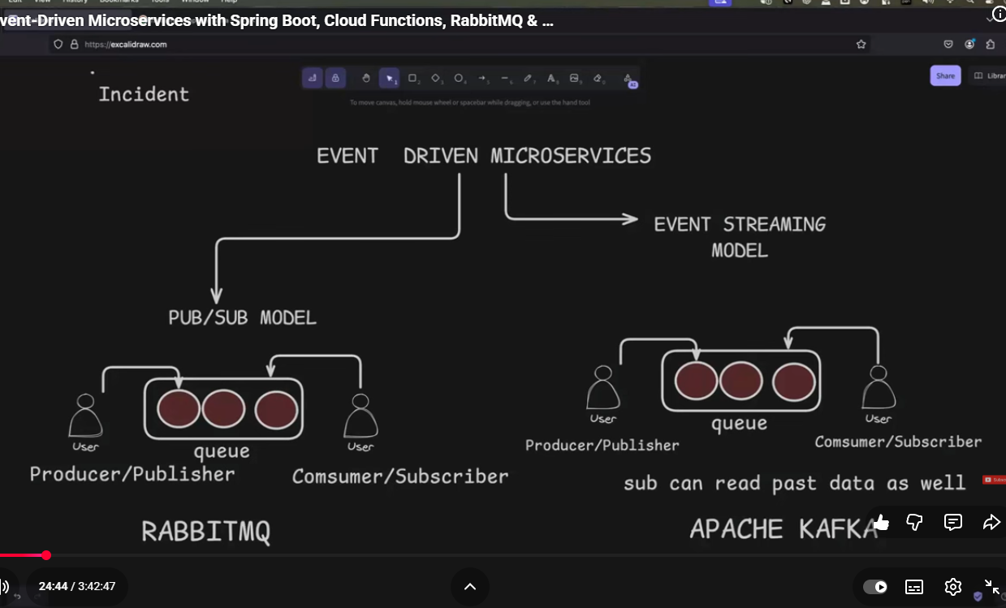
What is difference b/w Apache Kafka & Rabbit MQ?????
Kafka vs RabbitMQ? Difference between Kafka and RabbitMQ - AWS
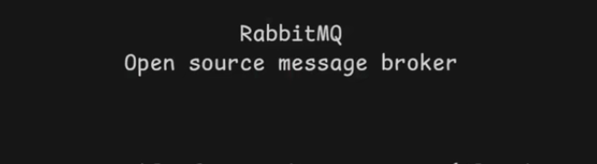
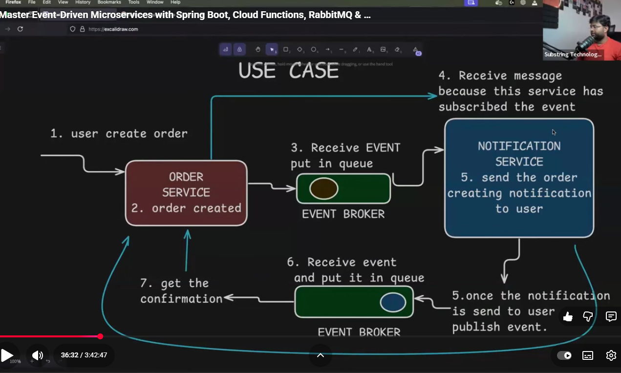
Event Broker = Rabbit MQ
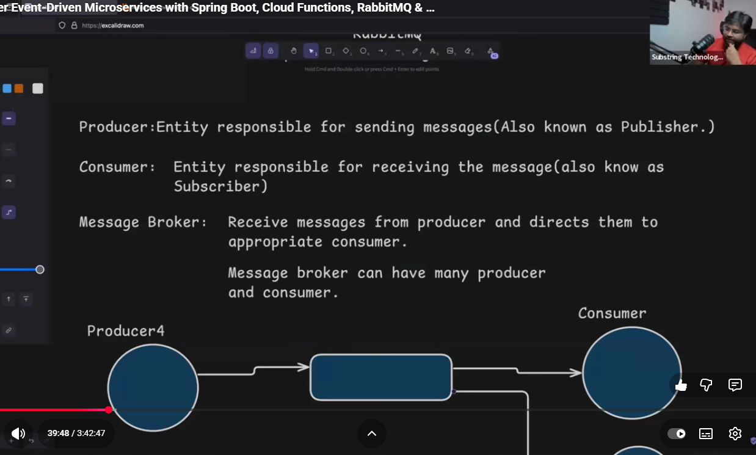
ARCHITECTURE
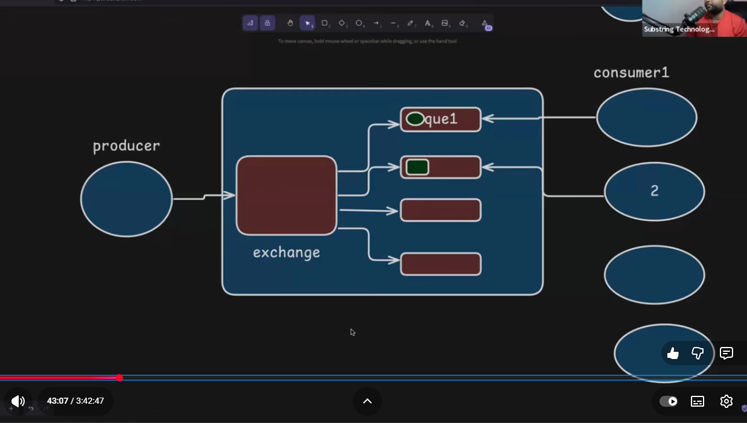
Exchange is responsible to decide in which queue event will be stored.
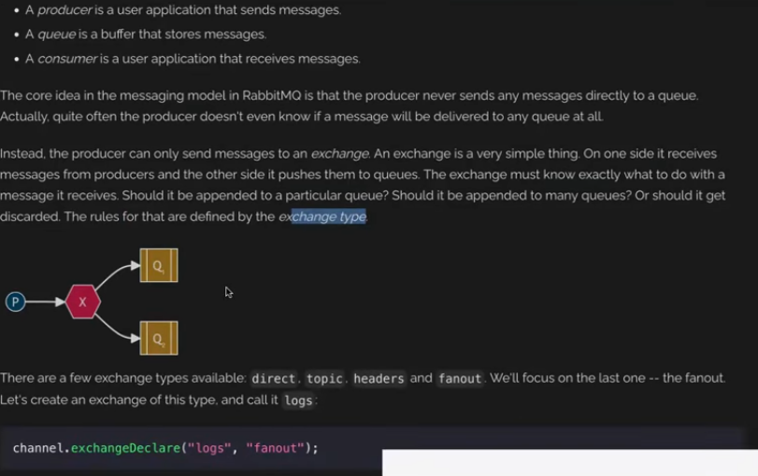
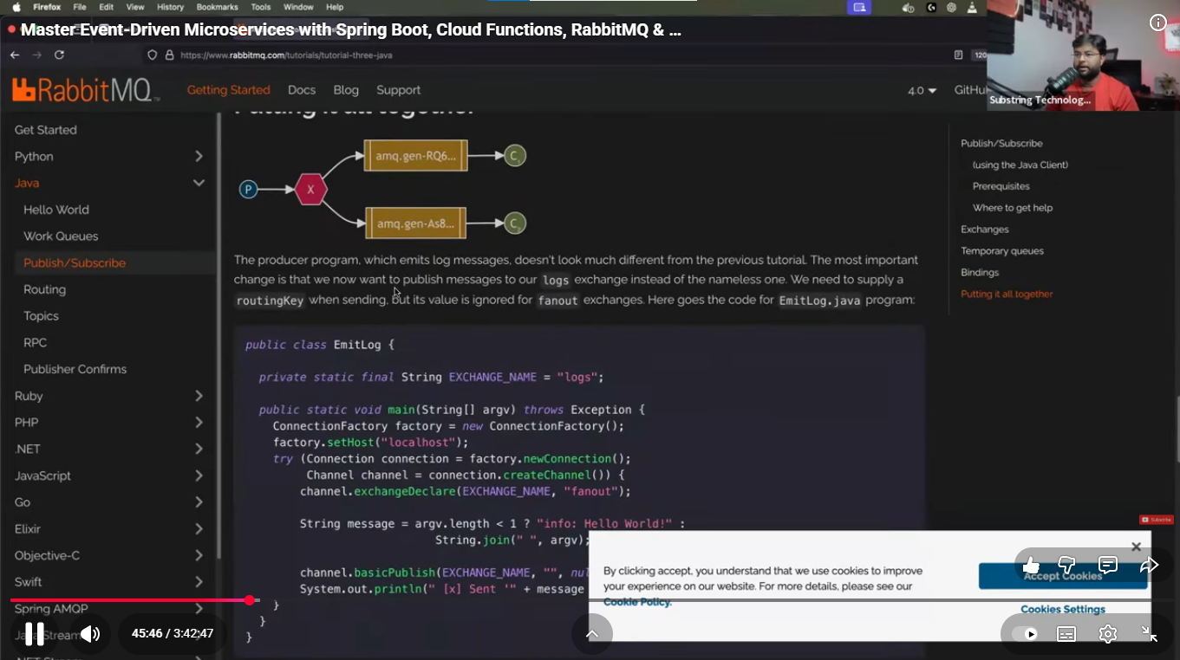
Spring Cloud Stream
Spring Cloud family
we use spring cloud gateway
spring cloud config
spring cloud Circuit Breaker
Spring Cloud Netflix
Spring cloud open feign
Spring Cloud Stream : help us to create Event Driven Microservices.
Binders act as a bridge between Appn & Message Broker. BINDER handles low level details for connecting, sending, receiving messages.
Spring Cloud Stream Components : https://youtu.be/fd_aS3ZSkxk?t=3217
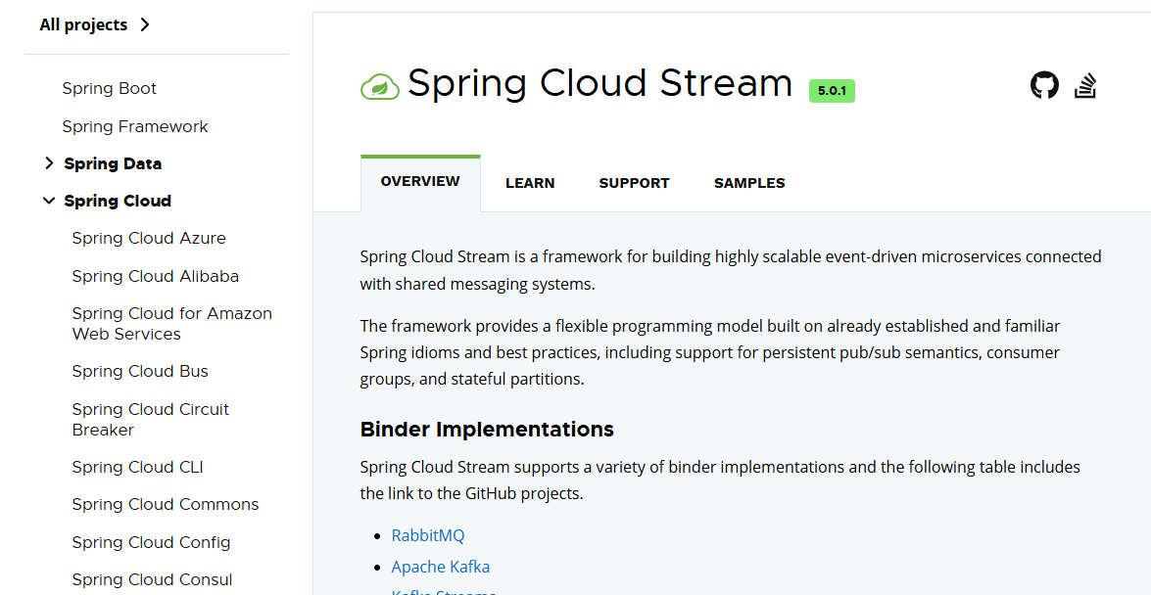
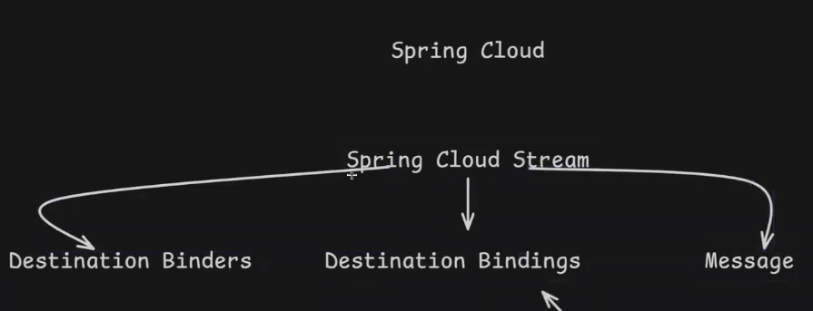
The core building blocks of Spring Cloud Stream are:
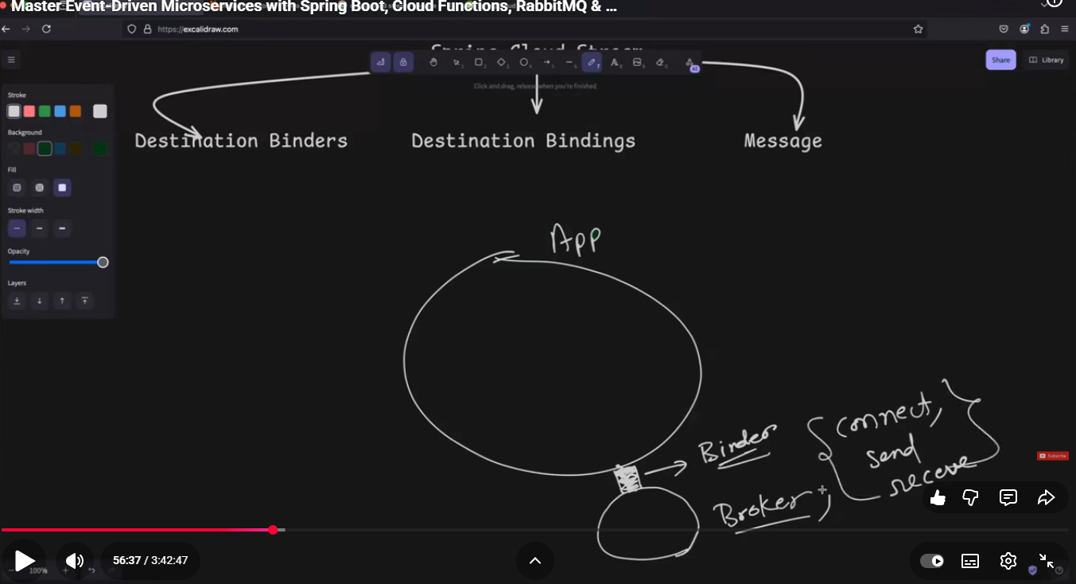
Binders: Atc as a bridge b/w application & message brokers.Responsible to connect, receive & send the messages.
Binders act as a bridge between Appn & Message Broker. BINDER handles low level details for connecting, sending, receiving messages.
Binding : tells us how I/p & o/p channel OF OUR appln is connected TO THE MESSAGING SYSTEM by binder.
https://youtu.be/fd_aS3ZSkxk?t=3680
In other words In which destination producer send tha data & from which destination consumer receive data.
Destination can be queue/topic
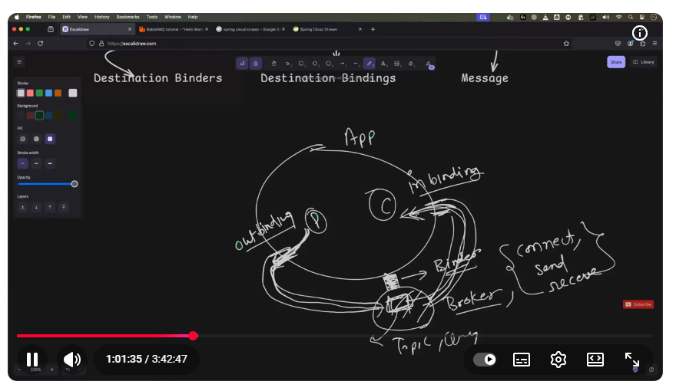
RabbitMq Impl starts: https://youtu.be/fd_aS3ZSkxk?t=3732
Spring Cloud Function : we can create endpoint (api)
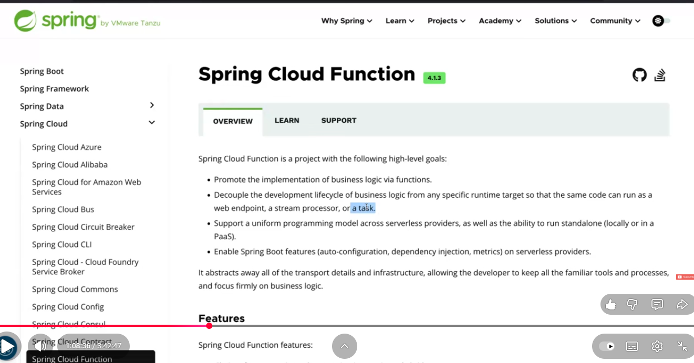

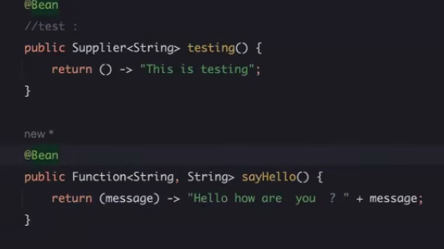
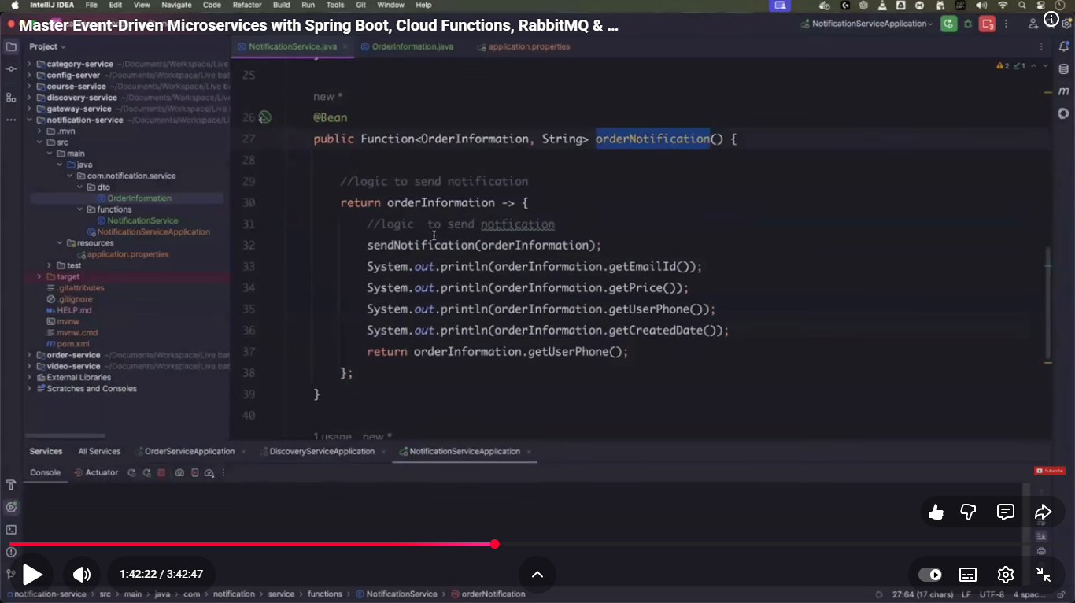
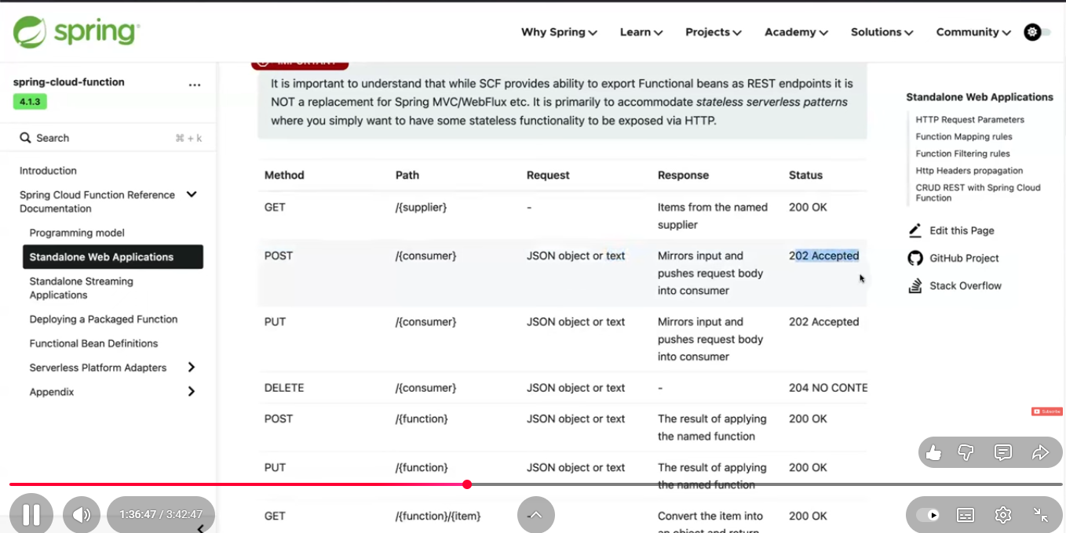

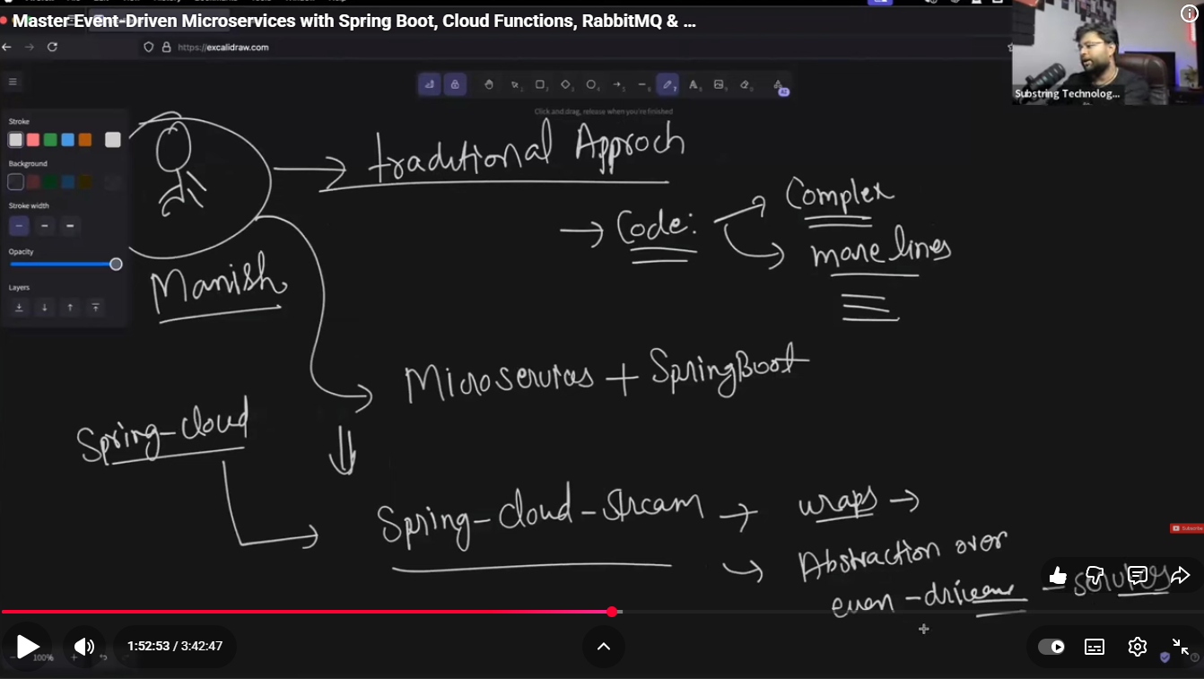
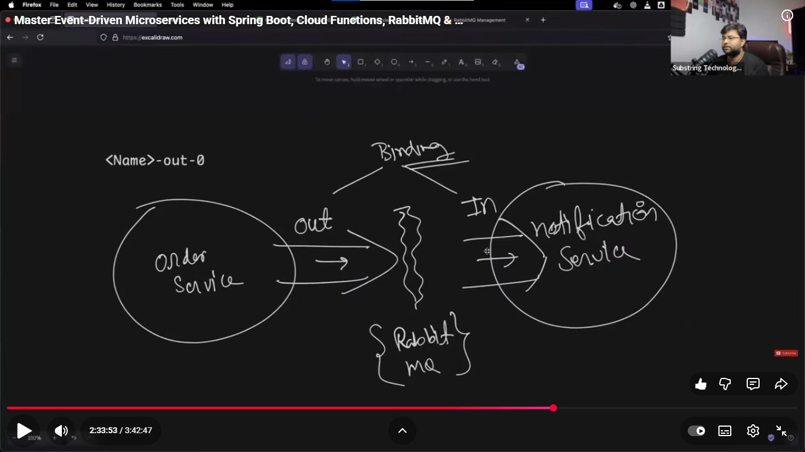
https://youtu.be/fd_aS3ZSkxk?t=7976
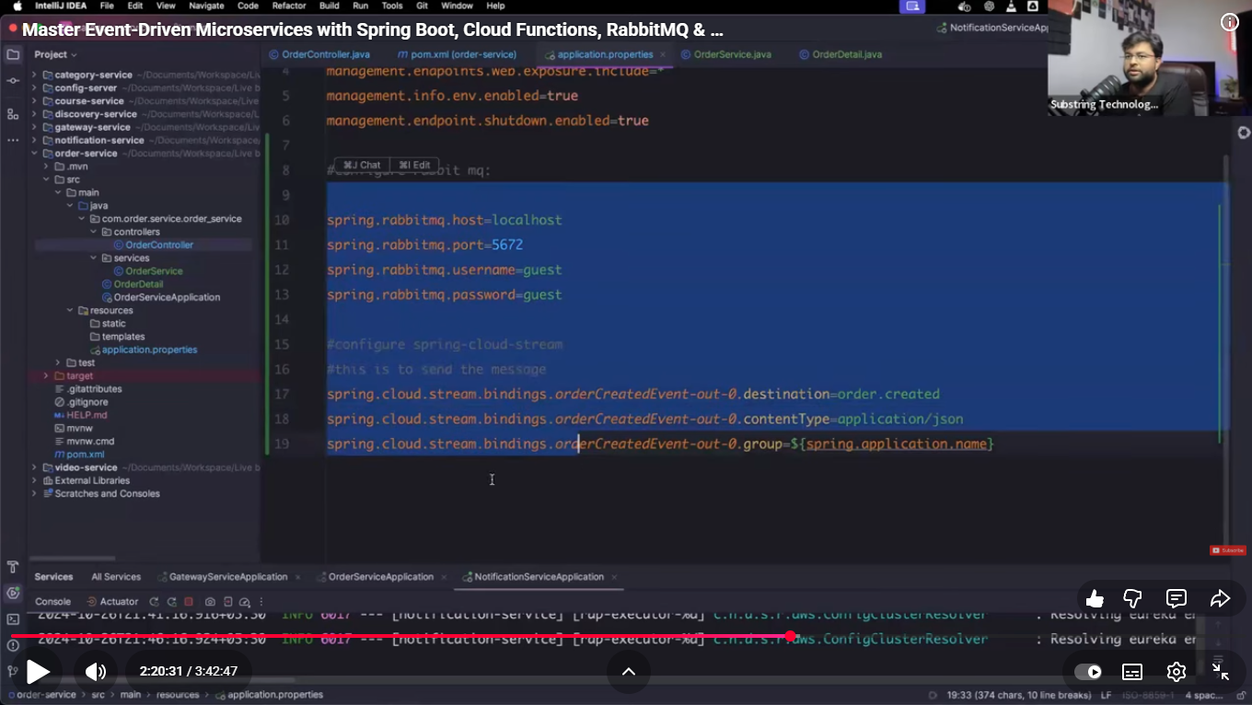

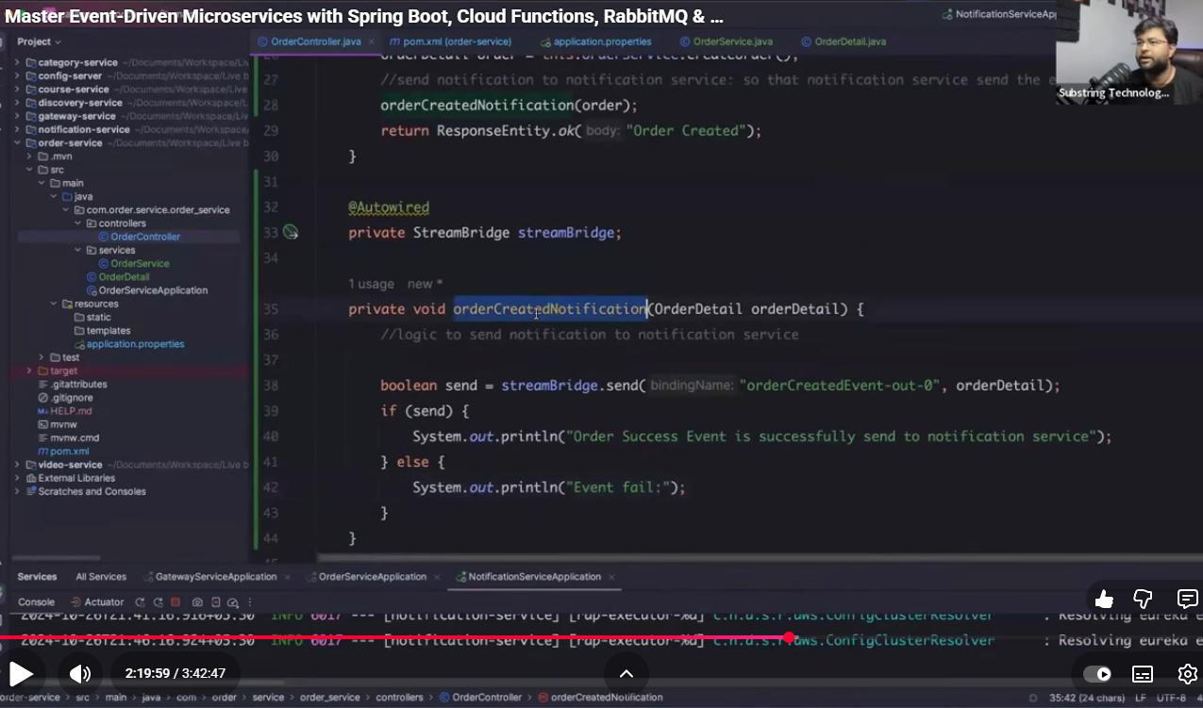
Consumer
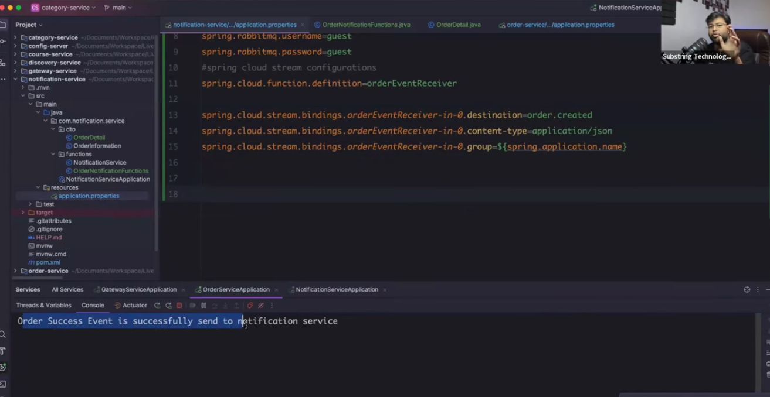
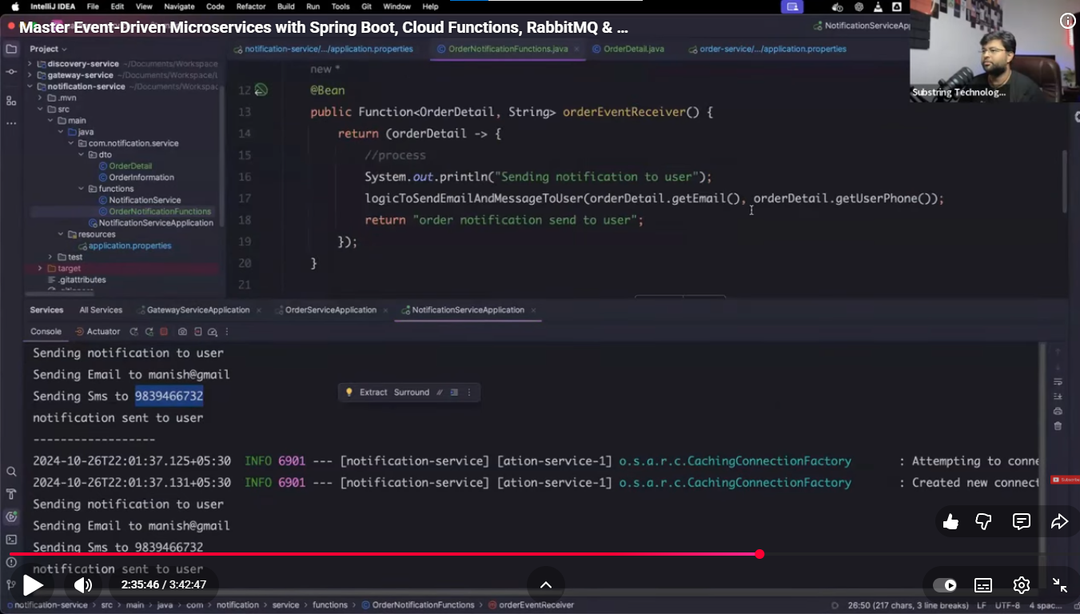
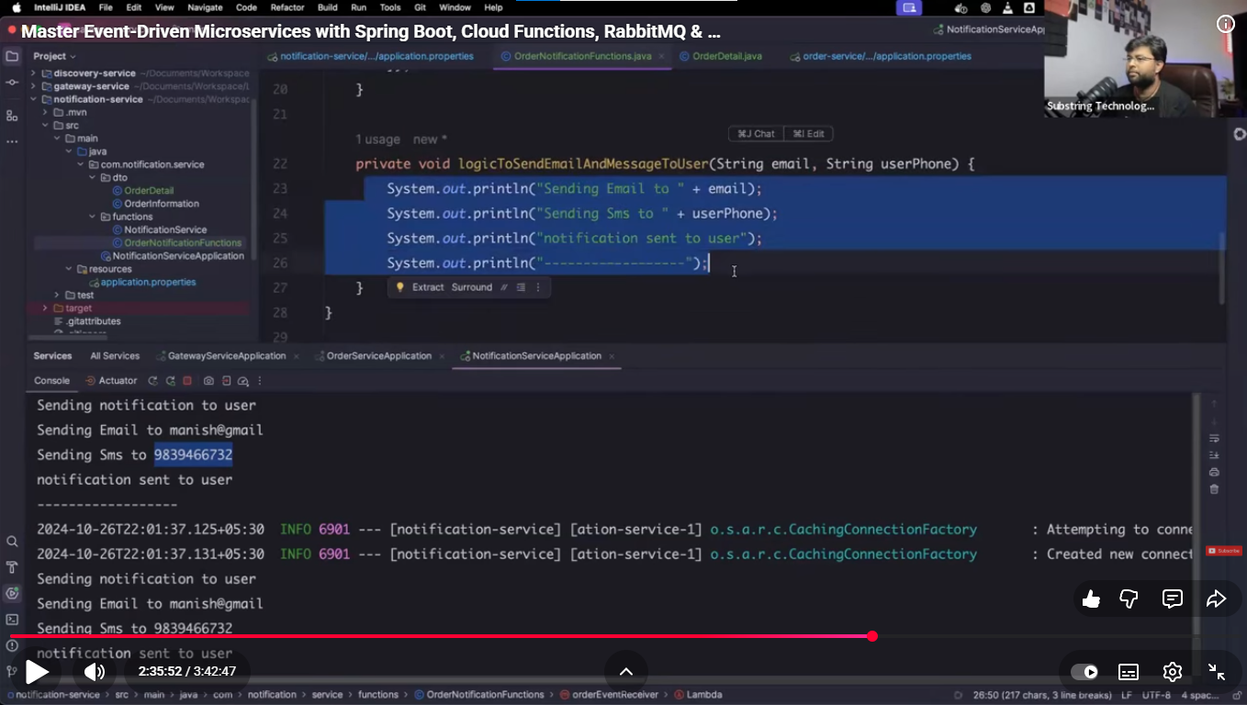

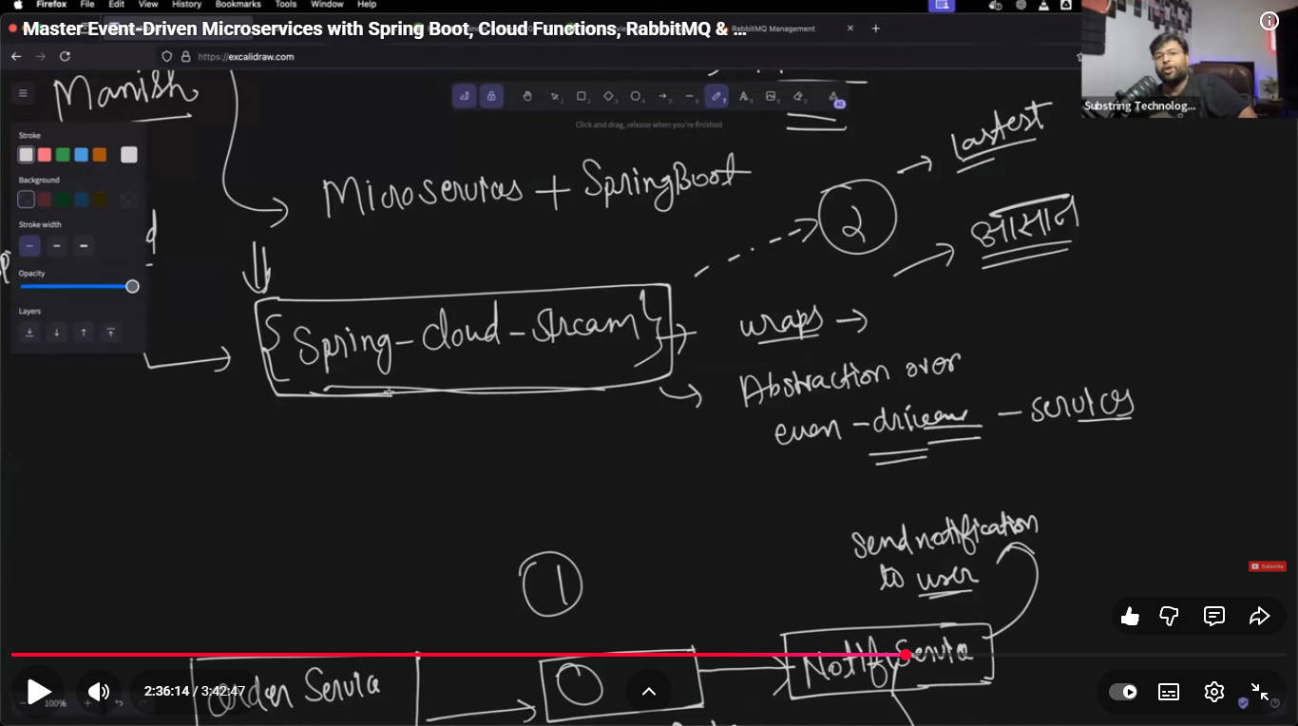
https://youtu.be/fd_aS3ZSkxk?t=8897
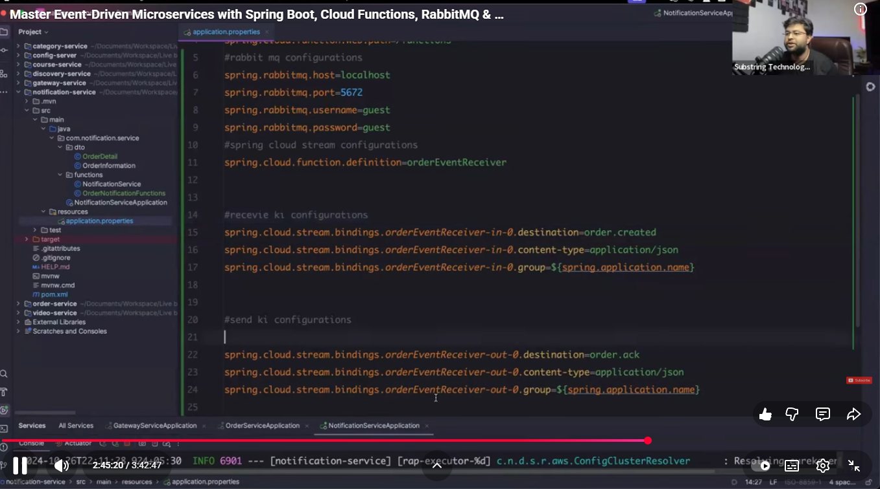

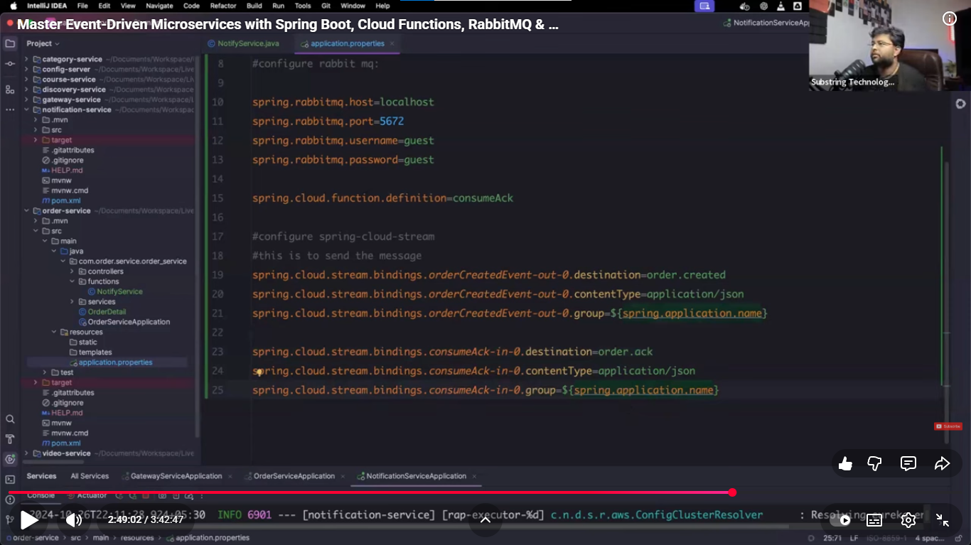
https://youtu.be/fd_aS3ZSkxk?t=10646
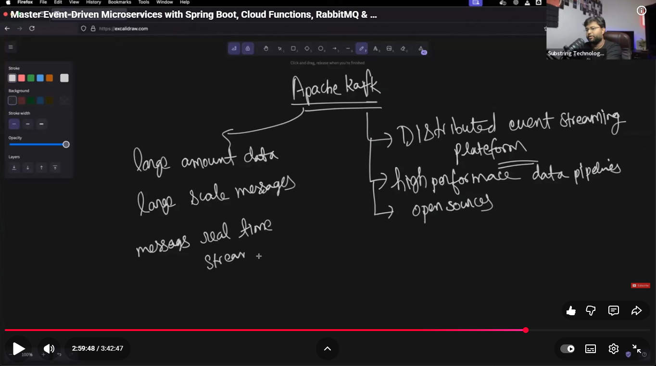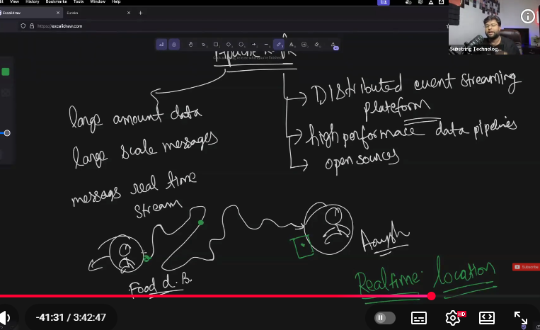
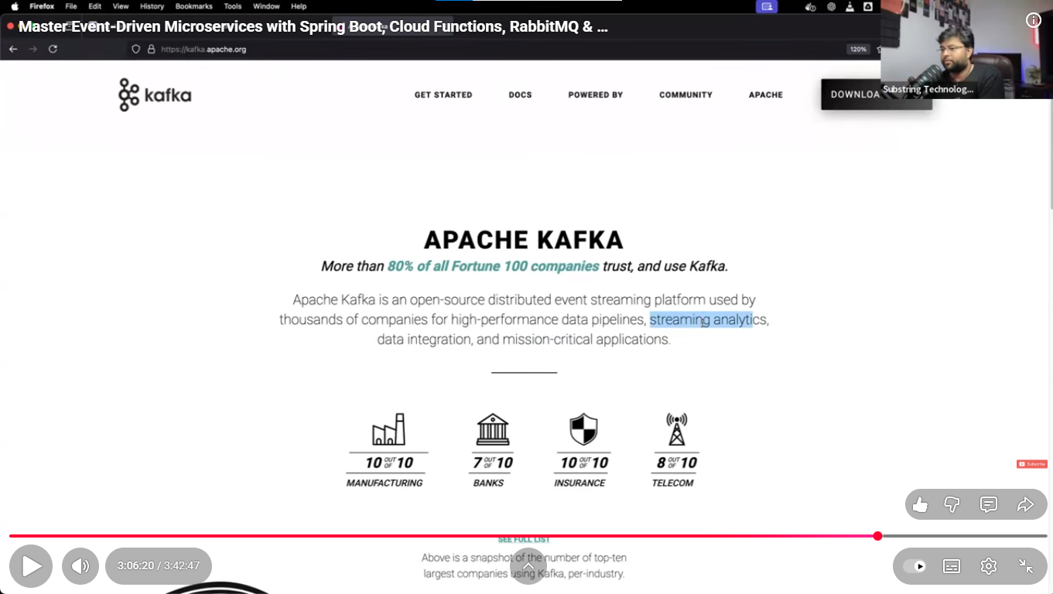
APACHE KAFKA: It is open-source & distributed event streaming platform which is designed for high performance data pipelines, also handle large amount of data and stream the messages in real time.
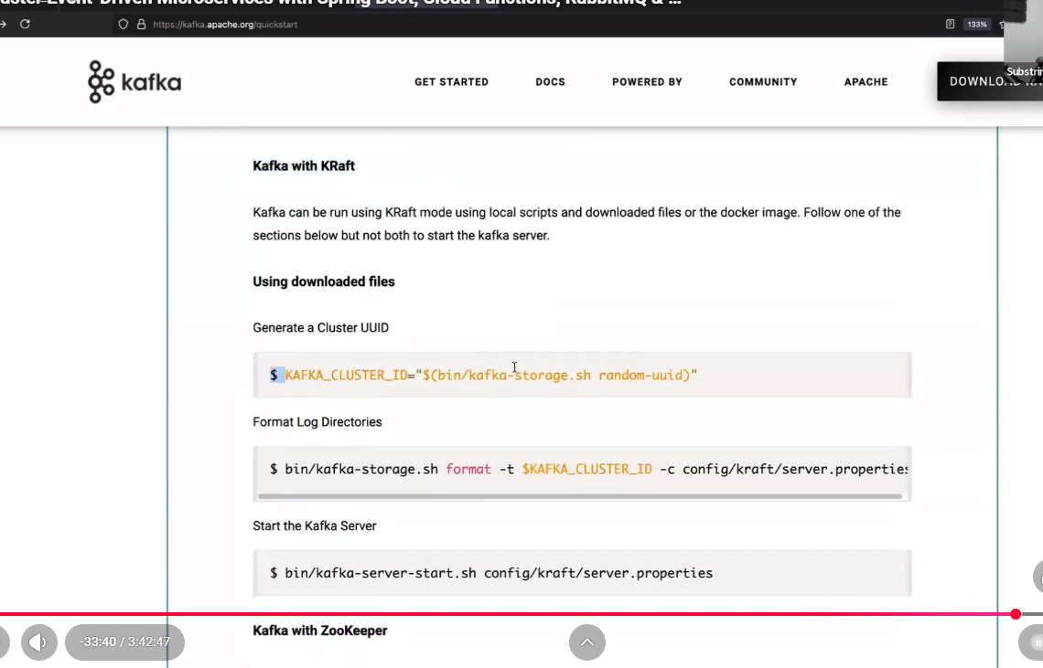
To understand completelty Architecture of Apache kafaka – javaTpoint, GFGeekks
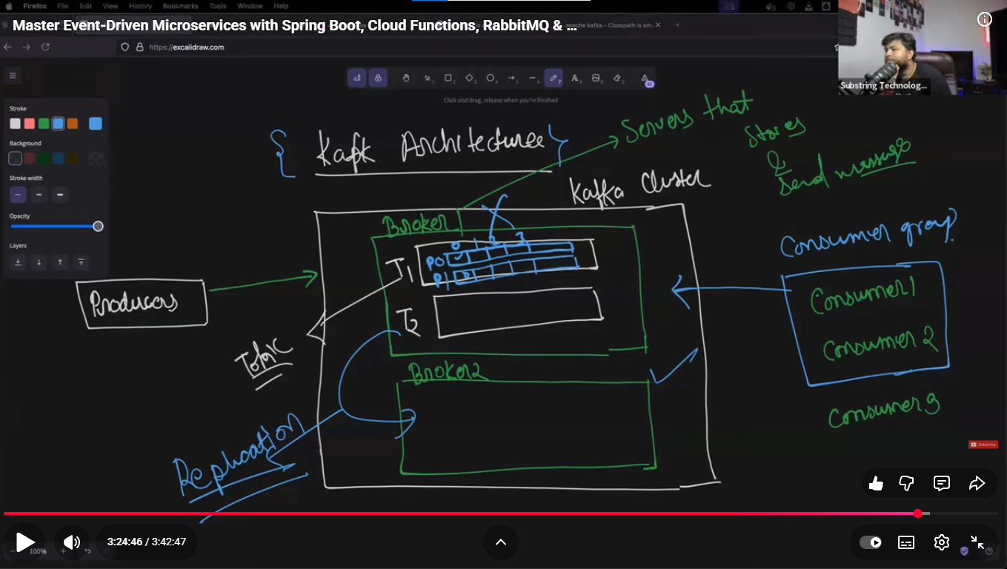
Inside KAFKA cluster there can be no. of broker(kafka server)
Good parac 3 brokers inside kafka cluster.
Brokers are the server that stores(receives) & send messages.
There can be n number of consumers.
When Producer produces data/event, THEN data comes in a broker that data will be stored in Topic format.
Topic helps us to categorize data means email related data will go email topic, orders related data will go order topiv.
Data/ event will be kept in partition inside appropriate topic.
when data placed in partition then a unique id/offset will be given that data, Broker identify the message by using that given id/offset.
Offset id
There can be consumer groups, that group subscribe the topic, when data comes in topic then immediately consumer consume the data.
Kafka uses replication that’s why data does not store in single server it will be stored in multiple server in order that lost data can be found another broker.
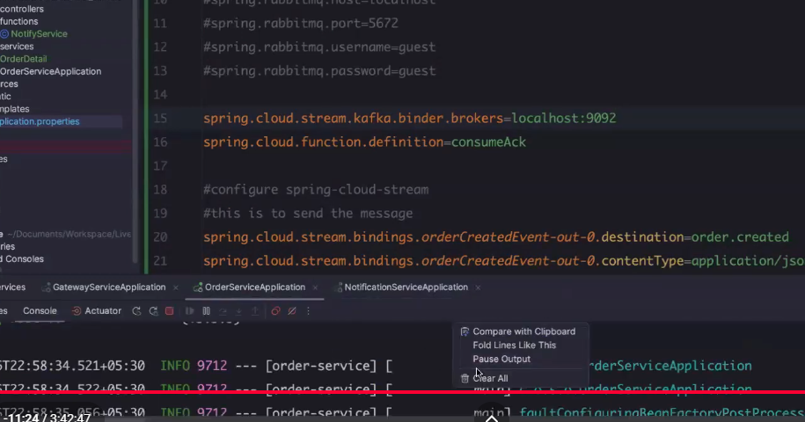

NEW
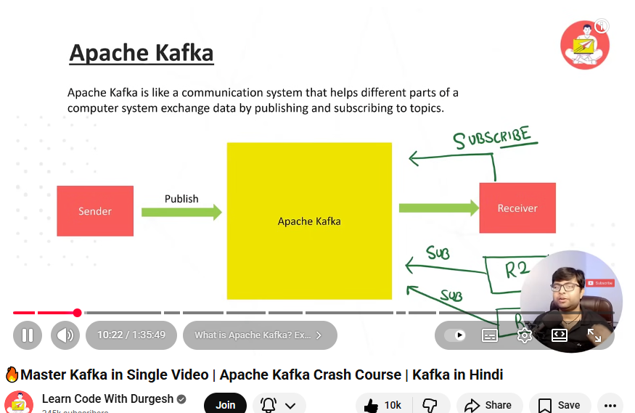
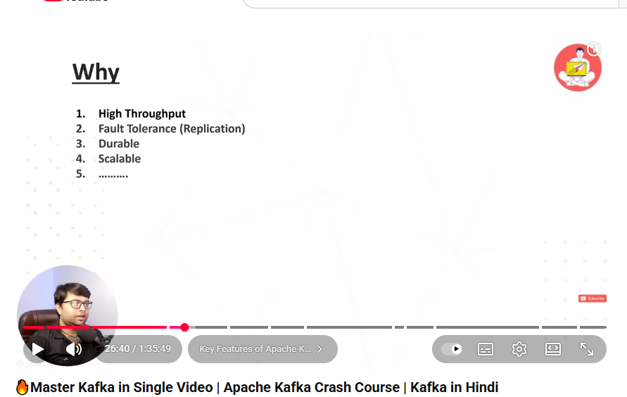
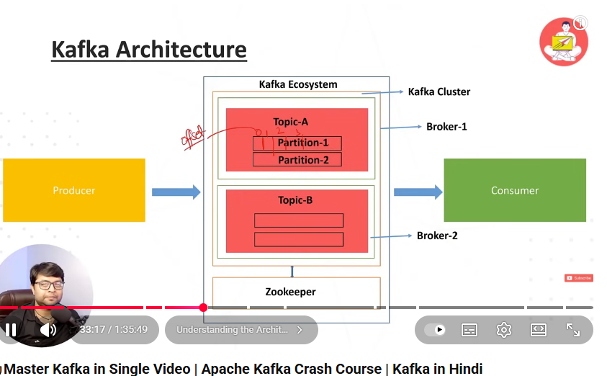

Customizing web security
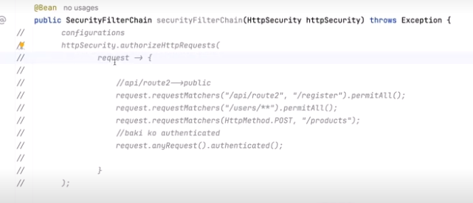
SAGA pattern #systemdesign #microservicesarchitecture #distributedcomputing
SAGA DESIGN PATTERN
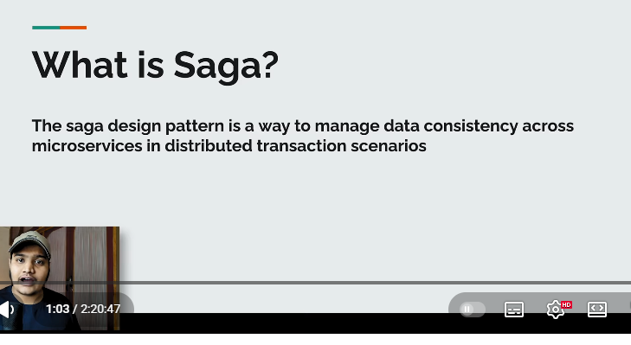
Saga Design Pattern : is the way to manage data consistency across the microservices in distributed transaction scenarios.
Saga helps ensure that the entire process completes successfully or rolls back to maintain consistency.

When user placed the order, payment will be deducted after that inventory will be deducted from db then shipping updated.
if all the steps passed then notification will be sent to user, order placed successfully.
If even one step gets failed then data needs to corrected and send notification to user “oder is not not placed & try again”

There are two ways to implement it
1.> Orchestration.
2.> Choregraphy.
Orchestration : There is orchestrator service where we write all logic regarding data consistency, Lets say we placed order for 1000 Rs, 1000 rs deducted , inventory gets -1 but order gets failed in shipping. We write logic in orchestrator service that inventory should be added with +1 & payment need to be refund.
Choreography(event-driven): As the order created , even registered in kafka then All three services read event from kafka then the services started for their working if any service gets failed then failure event registered in kafka, based on failure event , rest two services read event from kafka and rollback their work
Amazon/order

Inventory
Payment
Shipping

SHUTTLE
01:
As we scale in a distributed system, we often find ourselves in problems like:
- Handling large-scale data streams in distributed systems.
जब हम किसी डिस्ट्रिब्यूटेड सिस्टम को बड़े स्तर पर ले जाते हैं, तो अक्सर हमें इन समस्याओं का सामना करना पड़ता है:
• डिस्ट्रिब्यूटेड सिस्टम में बड़े पैमाने पर डेटा स्ट्रीम को संभालना।
• सर्विसेज़ के बीच 'टाइट कपलिंग' (बहुत ज़्यादा निर्भरता) को रोकना ताकि वे स्वतंत्र रूप से विकसित हो सकें।
• फॉल्ट टॉलरेंस (सिस्टम की खराबी सहने की क्षमता) सुनिश्चित करना और डेटा लॉस को रोकना।
KAFKA
Kafka एक हॉरिजॉन्टली स्केलेबल, फॉल्ट-टॉलरेंट और तेज़ मैसेजिंग सिस्टम है। यह एक पब-सब (pub-sub) मॉडल है जिसमें कई प्रोड्यूसर और कंज्यूमर डेटा लिख ​​और पढ़ सकते हैं। यह सोर्स और टारगेट सिस्टम को एक-दूसरे से अलग (decouple) रखता है। इसकी कुछ मुख्य विशेषताएं इस प्रकार हैं:
• सैकड़ों नोड्स तक स्केल करने की क्षमता
• प्रति सेकंड लाखों मैसेज हैंडल कर सकता है
• कम लेटेंसी: 2ms तक कम
• हाई थ्रूपुट: 100s MB/s और 100Ks मैसेज/s 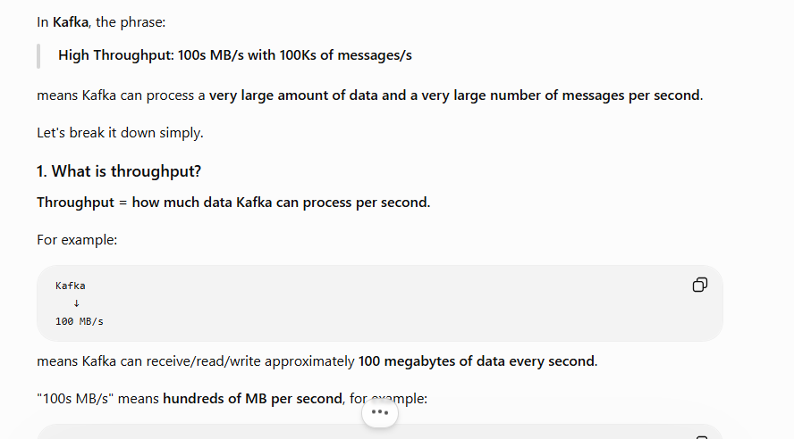
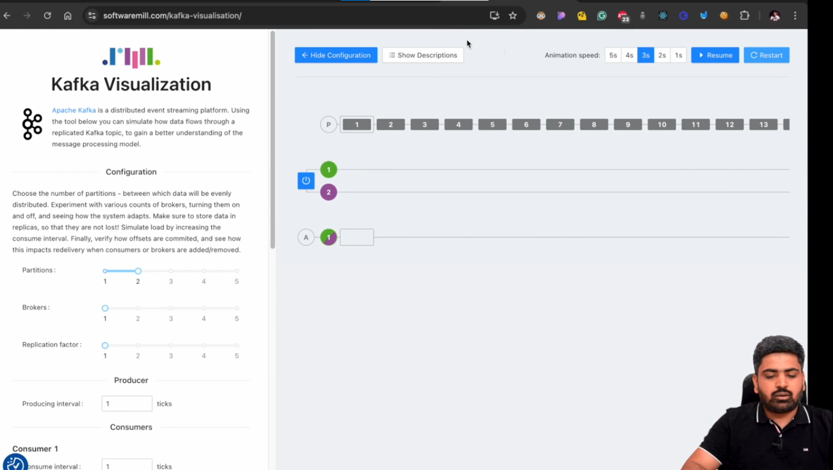

-:KAFKA NOTES:-
Problem Statement: In distributed system data is not keeping in centralised location rather it is distributed in different different locations that means we can get the data like no SQL or SQL or other devices.
As we scale in a distributed system, we often find ourselves in problems like:
• Handling large-scale data streams in distributed systems.
• Preventing tight coupling between services to allow independent evolution.
• Ensuring fault tolerance and preventing data loss.
Kafka: Kafka is horizontally scalable, fault tolerant and fast messaging system. It’s a pub-sub model in which various producers and consumers can write and read. It decouples source and target systems. Some of the key features are:
• Scale to 100s of nodes
• Can handle millions of messages per second
• Low latency: as low as 2ms
• High Throughput: 100s MB/s with 100Ks of messages/s

Use cases of Kafka:
Use Kafka for:
• Real-time data streaming
• Log aggregation
• Event sourcing
• Messaging
• Batch data processing
Do NOT use Kafka for:
• Simple Request-Response Communication
• Small-Scale Projects
• High Latency Tolerance
• Monolithic Applications
> LinkedIn uses Kafka to process 1 Billion messages per day!
Key Terminologies
Producer, Consumer, Events, Cluster, Broker, Topic, Partitions, and Offsets
Kafka Topic:
A topic is a specific stream of data. The topic is split into partitions that enable topic to be distributed across various nodes.
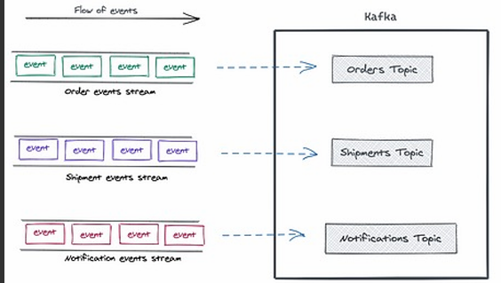 Some topic names for Ecommerce Application would be: order-placed, order-shipped, inventory-updated payment-processed.
Topic Partitions:
Kafka topics are subdivided into partitions, which are the basic unit of parallelism in Kafka. Each partition is an ordered, immutable sequence of records.
• Data within a partition is assigned a unique, incremental offset to track the order of messages.
• Partitions allow for scalability, as data can be distributed across multiple brokers, enabling horizontal scaling and concurrent consumption by multiple consumers.
Offsets: In Kafka, the purpose of an offset is to remember the position of a message inside a partition.
Think of it like a bookmark in a book.
PARTITION OFFSET:
Offset is a unique identifier assigned to each record within a partition. Offsets are sequential integers that mark the position of a message in a partition. Each record within a partition has a unique offset, starting from 0. Consumers can specify where they want to start reading by providing an offset (e.g., the most recent offset, or offset 0 to read from the beginning).
Consuming Topics:
For a topic with multiple partitions, Kafka assigns a partition in a round-robin fashion, but users can also implement custom partitioning logic (e.g., based on a message key).
Consumers read messages from partitions, tracking the last offset they consumed.
Kafka does not automatically delete messages once they are consumed.
it keeps messages based on a configured retention policy (e.g., 7 days or 100 GB per partition). Kafka provides the flexibility to reprocess messages by reading from an older offset.
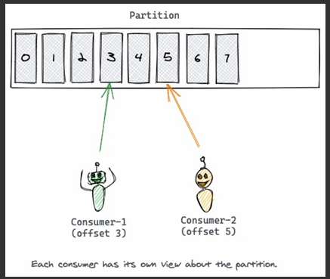
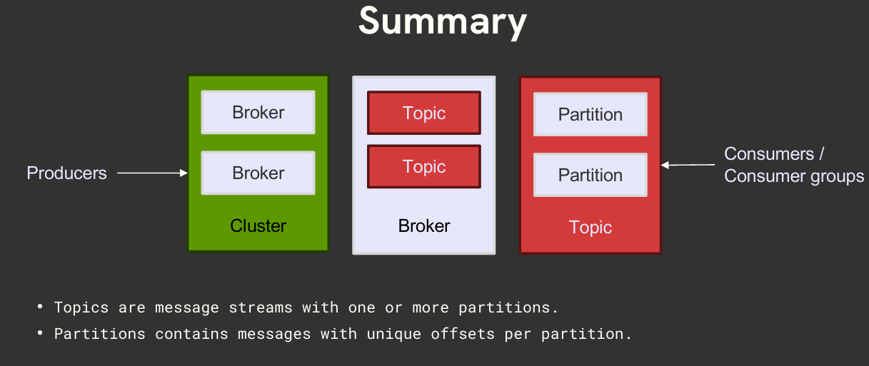
Partitioning Logic: A producer can use a partition key to direct messages to a specific partition. A partition key can be any value that can be derived from the application context. A unique device ID or a user ID will make a good partition key. If a producer doesn't specify a partition key when producing a record, Kafka will use a round-robin partition assignment.
Messages with the same key are always written to the same partition, and Kafka ensures that consumers receive them in the order they were produced. However, if no partition key is used, the ordering of records can not be guaranteed within a given partition.
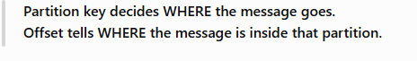
Reading records from Partitions:
Unlike the other pub/sub implementations, Kafka doesn't push messages to consumers. Instead, consumers have to pull messages off Kafka topic partitions. A consumer connects to a partition in a broker, reads the messages in the order in which they were written.
By remembering the offset of the last consumed message for each partition, a consumer can join a partition at the point in time they choose and resume from there. That is particularly useful for a consumer to resume reading after recovering from a crash.
But this may create a problem where multiple consumers instances of the same type read the record of a Kafka topic. To avoid this, Kafka has a concept called Consumer Groups.
Consumer Groups
The consumer group concept ensures that a message is only ever read by a single consumer in the group.
When a consumer group consumes the partitions of a topic, Kafka makes sure that each partition is consumed by exactly one consumer in the group.
The maximum parallelism of a group will be equal to the number of partitions of that topic. The number of consumers don't govern the degree of parallelism of a topic. It's the number of partitions.
NOTE:
Within one consumer group, the maximum number of consumers that can actively process a topic in parallel is equal to the number of partitions of that topic
Kafka cannot give two consumers the same partition within the same consumer group.
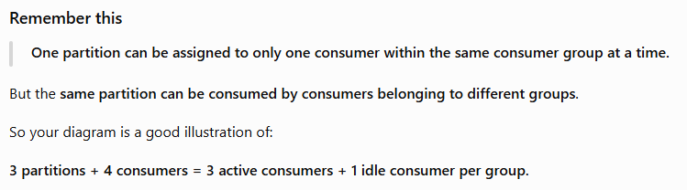
Rebalancing
Rebalancing is the re-assignment of partition ownership among consumers within a given consumer group such that every consumer in a consumer group is assigned one or more partitions. Rebalancing happens when:
• A new consumer joins the consumer group
• An existing consumer goes down
• New partitions are added
• An existing consumer is considered dead by the Group coordinator
The first consumer that joins a consumer group is called the Group Leader of that consumer group
Partition Replication:
Replication is making a copy of a partition available in another broker.
Replication enables Kafka to be fault tolerant. When a partition of the topic is available in multiple brokers then one of the partitions in a broker is elected as leader and rest of the replication of partition are followers.
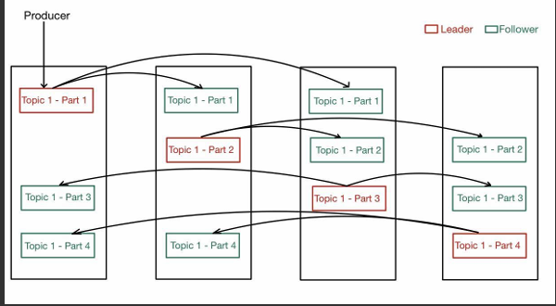
Kafka Brokers Management
Different brokers store partition replicas, with one of the brokers being the designated leader for each partition. A controlling mechanism that keeps track of the state of topics, partitions, and brokers is needed for such an architecture to work.
Kafka now uses the Raft consensus protocol to manage the metadata and the state of the Kafka brokers.
In KRaft mode, brokers coordinate directly with each other to elect a leader and replicate state across the cluster, eliminating the need for a separate system like Zookeeper.
Kafka Log Retention:
Kafka's log retention controls how long messages are kept in a topic. Messages are stored on disk, and Kafka can retain them based on time (retention.ms) or size (retention.bytes), whichever comes first. Once the retention limit is reached, old messages are deleted in the background. Kafka can also be configured to retain messages indefinitely (retention.ms=-1), but this could lead to high storage costs if not managed carefully.
Acks and Retries
acks
The acks configuration determines the number of acknowledgments the producer requires from the broker before considering a request complete. It has three possible settings: 0, 1 and all (-1)
0: The producer does not wait for any acknowledgment from the broker, fastest, but offers no guarantee that the message has been received or written to the broker.
1: The producer will receive an acknowledgment as soon as the leader broker has received the message.
All: The producer will wait for acknowledgments from all in-sync replicas (ISRs) before considering the message sent
Acks and Retries
retries
If a send request fails (for example, due to a temporary network issue or a broker being down), the producer will automatically retry sending the message up to the number specified by the retries configuration. This is useful for ensuring that transient issues do not result in message loss.
When combined with acks=all, the producer can retry sending messages that have not been acknowledged by all replicas. This ensures that even if there are issues with one of the brokers, the message can still be sent to the other available brokers
https://softwaremill.com/kafka-visualisation/
MY SUMMARY: A topic is a specific stream of data. The topic is split into partitions which are the basic unit of parallelism in Kafka that enable topic to be distributed across various nodes. topics have offsets per partitions. You can uniquely identify a message using its topic, partition and offset. Data within a partition is assigned a unique, incremental offset to track the order of messages.
Each record within a partition has a unique offset, starting from 0.
Offsets are sequential integers that mark the position of a message in a partition.
Consumers can specify where they want to start reading by providing an offset (e.g., the most recent offset, or offset 0 to read from the beginning).
In Kafka, the purpose of an offset is to remember the position of a message inside a partition.
Think of it like a bookmark in a book.
NOTE: Kafka does not automatically delete messages once they are consumed. it keeps messages based on a configured retention policy (e.g., 7 days or 100 GB per partition). Kafka provides the flexibility to reprocess messages by reading from an older offset.

